Field Mapping Tasking Manager Task Status to Tasking Manager
Object Sequence Diagram
@startuml
Participant “Field Mapping Tasking Manager” as FTM
Participant “Tasking Manager” as TM
FTM -> TM: UpdateTask(Task Status, TM Task Id, FTM Task Id?)
TM -> TM: Update Task
TM -> TM: Do Something with Task Id?
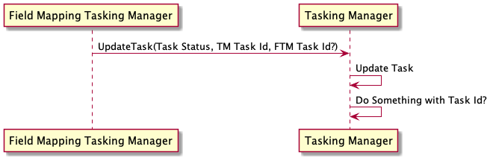
@enduml

